**<D2.1.2 Documentation of the Corpora>**

ModelWriter

Text & Model-Synchronized Document Engineering Platform

Work Package: WP2

Task: 2.1 – Data Collection

Edited by:

Claire Gardent <claire.gardent@loria.fr> (CNRS / LORIA)

Mariem Mahfoudh <mariem.mahfoudh@loria.fr> (CNRS / LORIA)

Samuel Cruz-Lara <samuel.cruz-lara@loria.fr> (University of Lorraine / LORIA)

Anne Monceaux <anne.monceaux@airbus.com> (AIRBUS Group)

Date: 2-Sept-2015

Version: 1.0.0

Apart from the deliverables which are defined as public information in the Project Cooperation Agreement (PCA), unless otherwise specified by the consortium, this document will be treated as strictly confidential.

Document History

|  |  |  |  |
| --- | --- | --- | --- |
| Version | Author(s) | Date | Remarks |
| 0.1.0 | Claire Gardent, Mariem Mahfoudh, Samuel Cruz-Lara  Anne Monceaux | 2-Sept-2015 | Draft |
| 1.0.0 | Claire Gardent, Mariem Mahfoudh, Samuel Cruz-Lara  Anne Monceaux | 9-Sept-2015 | Initial Release |
|  |  |  |  |

0

Table of Contents

Document History 3

1. Introduction 5

1.1. Role of the deliverable 5

1.2. Structure of the document 5

1.3. Terms, abbreviations and definitions 5

2. Introduction 6

3. Airbus Data 8

3.1. Text 8

3.2. Models 9

3.3. Exploiting the Data 12

4. Obeo Data 14

Appendixes 18

Appendix 1 Airbus Data 18

Appendix 2 Obeo Data 18

1. Introduction
   1. Role of the deliverable

This deliverable documents the data used to train, develop and test the natural language processing (NLP) components (Semantic Annotator, Semantic Parser, Natural Language Generator) of ModelWriter. It might be updated during the project in case additional data is worked with.

* 1. Structure of the document

This document is organized as follows:

Section 1 introduces the document.

Section 2 describes for each use case: the scope and motivation, the approach and the available resources (corpora).

* 1. Terms, abbreviations and definitions

|  |  |
| --- | --- |
| Abbreviation | Definition |
| NLG | Natural Language Generation |
| NLP | Natural Language Processing |
| RDF | Resource Description Framework |
| RDFS | RDF Schema |
| UML | Unified Modelling Language |
| OWL | Web Ontology Language |
| IDE | Integrated Development Environment |
| EMF | Eclipse Modelling Framework |
| GUI | Graphical User Interface |
| JDT | Java Development Tooling |
| WP | Work Package |
| UC | Use Case |

1. Introduction

The development and the evaluation of natural language processing systems require data: for training, for tuning and for testing. In the ModelWriter project, this includes textual data, knowledge data and ideally bi-texts i.e., aligned corpora of text and their corresponding knowledge representation.

Based on the use cases identified in WP1, we collected data to develop and evaluate three NLP tools necessary to achieve ModelWriter goals, namely, a semantic annotator, a semantic parser and a natural language generator.

The semantic annotator is required to synchronise text and models. Its function is to annotate text with elements of the model or of the KB whereby text elements may differ from model/KB elements with respect to derivational (warn/Warning) or inflectional (pipe/Pipes) morphology, synonymy (pipe/tube) and/or syntax (procedure should be removed/procedure deletion).

A semantic parser converts text into model representations. It can be used to extend the model (by adding to the current model the model expression representing the meaning of the parsed text) or to synchronise complex natural language expressions with one or more model elements.

Conversely, a natural language generator maps model representations to text. It can be used to update a text which is synchronised with a model whenever this model is modified/extended.

During the first year of the ModelWriter project, we worked with and collected three main data types:

1. The texts that are technical documents describing the rules and the services of a company. They can be text files, pdf files, java files, etc. and they can contain both text (words, sentences, …) and pictures.
2. The models that are formal and structured representations of the technical documents (texts). They can be UML diagrams, conceptual models, RDFtriples etc.
3. The knowledge bases that are an explicit specification of a conceptualization of a domain. The knowledge bases provide a formal representation of domain knowledge and they can be RDFS or OWL ontologies.

Depending on the targeted application, texts will be annotated with either model or knowledge base elements. Thus, in the Obeo usecase (see Section 4), since the aim is to synchronise the code documentation with both the corresponding code and an ECORE model, the semantic annotator developed for this use case annotates text (code documentation) with either ECORE or Java concepts. In contrast, in the Airbus case, because the aim is to synchronise the system installation design principles (SIDP) documents with an OWL knowledge base describing the rules and the components described by the SIDP documents, the semantic annotator annotates text with KB elements. In sum, the knowledge bases and the models are used to annotate text and later on in the project, to represent the meaning of texts. The knowledge bases are also used to identify and check the consistency of the links between text and model.

Figure 1 represents the relations between the different types of data.

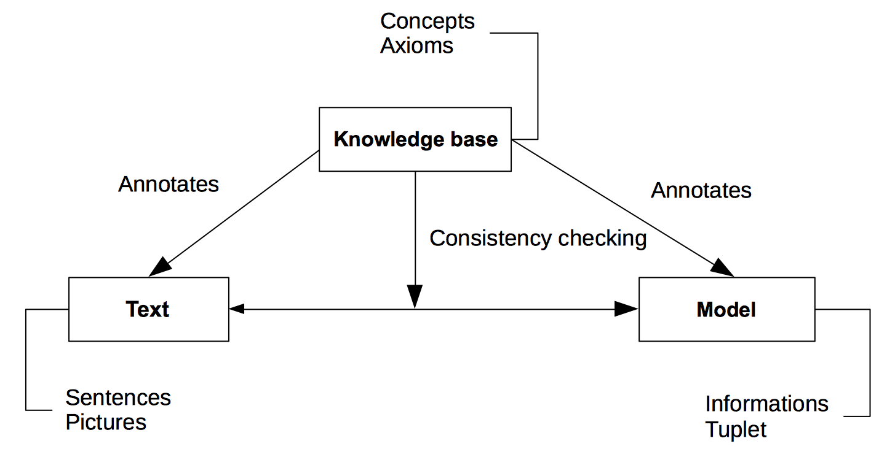

Figure 1: Text, Model and Knowledge Base.

The data described in this document will be used to identify the linguistic requirements set by the use cases; to train and test the semantic processors (parser and generator); and to acquire the language models useful for disambiguation (parsing) and fluency ranking (generation). The rest of this document is organized as follows: section 3 describes the Airbus corpora and section 4 describes the Obeo corpora.

1. Airbus Data

This section describes the Airbus corpora which is composed of a set of texts and a knowledge base (the model).

The Airbus use cases UC-FR4 and UC-FR5 target the synchronisation of Airbus SIDP (e.g. System Installation Design Principles) documents with an OWL model.

The overall driving need for these two use cases is to reduce the time and the burden for the designers to consult a large set of regulation documents in order to retrieve design rules. Due to reasons such as technology push, process changes, etc. an increasing number of different regulation documents are issued by different stakeholders. They contain a high number of informal rules and the designers have difficulties following the information cascade and retrieving or rebuilding the correct information. This situation results in time waste, suboptimal designs and higher risks of error. In ModelWriter, our ultimate goal is to remedy this shortcoming by providing a synchronization mechanism between these documents and a model encoding the rules contained in these documents This is an ambitious goal which in effect, requires building a semantic parser and a generator that can map arbitrary text into formal rules and vice versa. To achieve these goals, we started by gathering the following data.

* 1. Text

The text corpus is composed essentially of the System Installation Design Principles (SIDP). The SIDP documents are technical documents (doc files) that consists of various sets of regulations and directives about how to install a system or a set of systems in a functional area (e.g., electrical and optical system or Water Waste System). For each aircraft project, a set of such documents must be produced to ensure that the resulting system comply with the system requirements and take into consideration applicable regulations and procedures. Figure 2 presents an extract from a SIDP document. It shows a table that presents an example of component (”Bundle”) with its definition and its picture. The definition specifies the rule that must be respected in the system installation of this component.

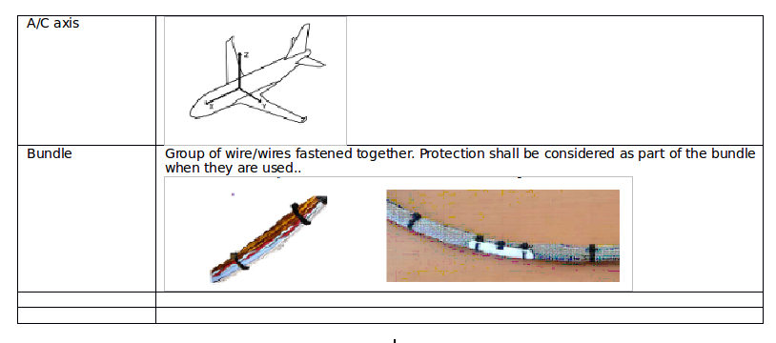

Figure 2: An extract from a SDIP document.

We gathered two text corpora for developing and testing our NLP tools:

* SIDP document SIDP 92A001V. This SIDP document contains the system installation design principles applicable to the electrical and optical system installation. It provides an example of how design rules are formulated in SIDP documents and of how these documents are structured. The SIDP document SIDP 92A001 includes text and graphics and contains 6311 word forms. It is a confidential document, made available under NDA only.
* Semi-Structured SIDP rules. The Airbus System Installation team has built an SQL database of SIDP rules which encodes installation rules in a semi-structured format. In effect these rules provide a simplified, semi-normalised version of the rules contained in the SIDP documents thereby facilitating natural language processing (less diversity in the syntactic structures and lexicon, less ambiguity, rules formulated as one sentence rather than across several sentences, fewer anaphoric references etc). Table 1 shows an example of an SIDP rule extracted from the database. It is a rule describing a segregation constraint holding between a pipe and an electrical route. This constraint is specified by Rule 1 and applies in the functional area ATA38 (i.e., the water waste system) and in aircraft Zone 1 (i.e this refers to a zonal safety breakdown of the aircraft).

We gathered these rules to develop a first version of the NLP tools (semantic annotator, semantic parser and text generator) that works on these semi-structured rules. Currently, the semi-structured rules available to the French consortium consists of 986 rules and 13178 word forms. These rules are available in two formats: an excel file whose columns are used to label each part of the rule (French-Consortium/airbus/text/rules.xls) and a text file where this labelling is ignored. (French-Consortium/airbus/text/rules.txt). The excel file is used to automatically construct an OWL version of the rules while the text file is used to test the NLP tools.

|  |  |  |  |  |  |  |  |
| --- | --- | --- | --- | --- | --- | --- | --- |
| ATA | Zone | Rule | Object | Auxiliary | Action Verb | Prep | Object 2 |
| 38 | 1 | 1 | pipe | shall be | segregated | from | electrical route |

Table 1: A rule from Airbus’ model.

* 1. Models

To support extended KB querying and synchronisation, Airbus further developed a knowledge base modelling the SIDP92A001V domain, namely the domain of the electrical and optical system installation. This knowledge base is composed of two OWL knowledge bases (Rule and Component ontology), specified using the OWL and the SKOS (Simple Knowledge Organization Systems) languages:

1. The Rule ontology represents the SIDP rules concepts. It was manually constructed and derived from the underlying data structure of the SQL semi-structured rules mentioned above. It is an OWL-DL ontology composed of 30 classes, 35 objectProperties and 54 dataProperties. It can be automatically populated with data exported from the SQL database (Excel file) and the resulting knowledge base contains 45781 triples. .

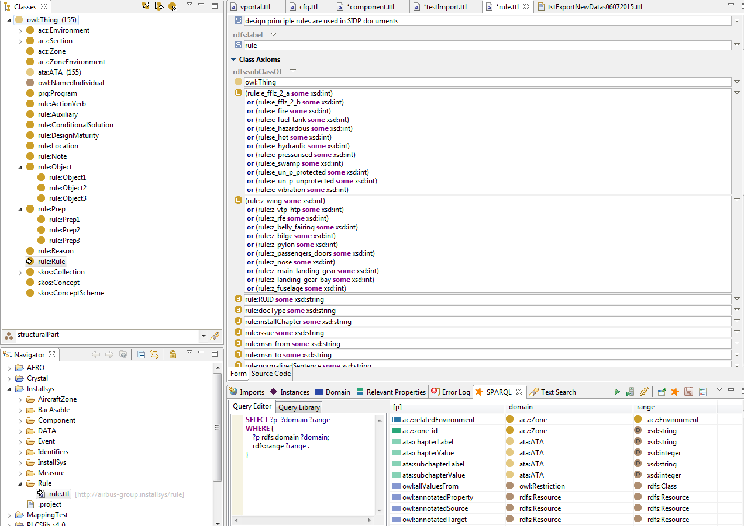Figure 1 - Screen shot of Rule ontology

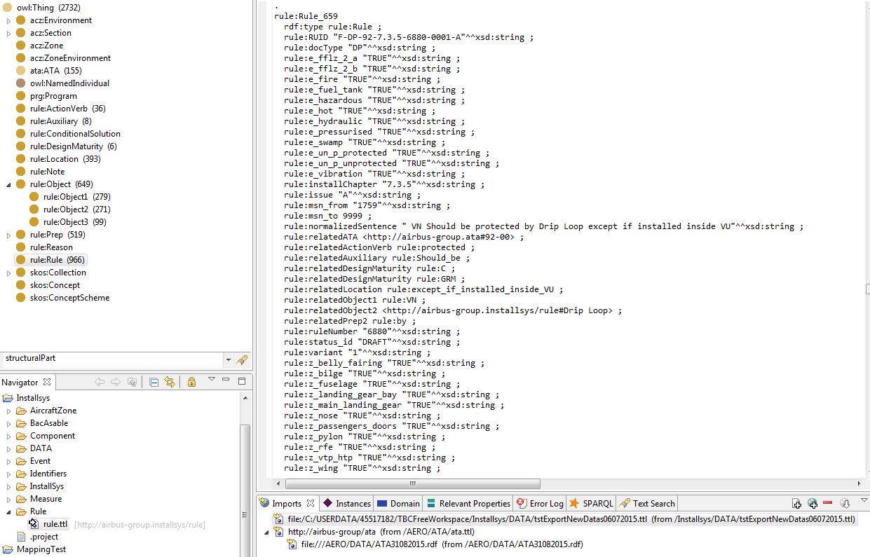

1. Figure 2 - Screen shot of the populated Rule ontology (ie the OWL database)The Component ontology represents the concepts and the vocabulary used in system installation rules to refer to both the components to be installed such as pipes, wires or equipment, and the means used for routing, connecting, isolating these components such as bolts, clamps, etc. This ontology is manually constructed by experts working at the Airbus company. It is an OWL-DL ontology and it is composed in its current version of 476 classes, 21 ObjectProperties and 35 DataProperties.Figure 3 presents an extract from this ontology.

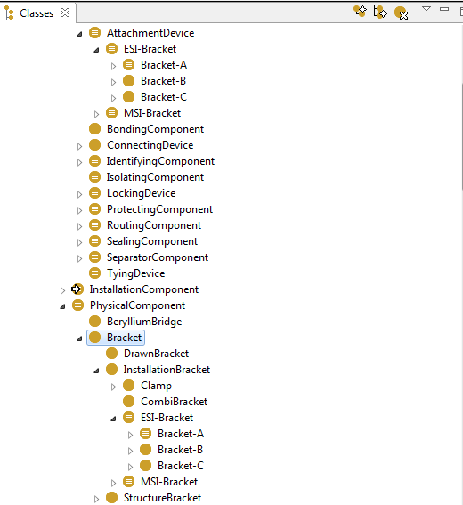

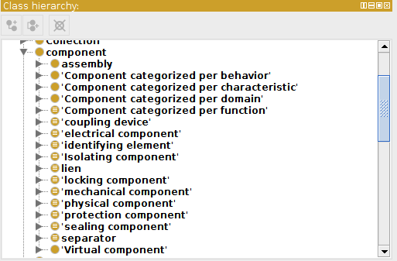

Figure 3: An extract from Component Ontology.

This knowledge base is used in different tasks. Firstly, it provides terminological information that can be used when proposing some semantic links between text and model (e.g. *link* is a synonym for *attach*). This is based on rdfs:label and skos label (skos:preflabel and skos:altlabel). Secondly, the knowledge base is used to verify the consistency of the created links using the ontologies axioms (e.g. disjointWith). Thirdly, the skos:definition labels are exploited to create a raw texts describing the components used by Airbus company.

* 1. Exploiting the Data

Because of confidentiality issues, the Airbus data could only be shared after a Non Disclosure Agreement was signed by all interested parties namely, all French partners. This agreement was finalised on June 1st and access to the data was given shortly thereafter.

During the first year of the project, we used the data as follows:

* Semantic Parsing maps text to meaning representations which can then be queried and synchronisation links text and model elements via semantic annotation. CNRS/LORIA developed a first prototype implementing a complete processing chain for mapping text to RDF, combining the resulting RDF database with RDFS schema modelling the domain ontology and querying the resulting RDFS Knowldege Base[1].
* The SIDP semi-structured rules were processed by AIRBUS to automatically construct an extensive OWL knowledge base encoding the content of these rules.
* The domain specific KB manually developed by AIRBUS was used by CNRS/LORIA for the semantic annotation of the SIDP rules. The current version of the semantic annotator can annotate arbitrary text with concepts from the domain specific KB developed by Airbus.
* The domain specific KB is also used to support SPARQL queries on the RDFS knowledge base automatically derived from the SIDP semi structured rules by allowing for e.g., subclass information to be taken into account. Suppose for instance that the KB includes the knowledge that hose pipes, electrical pipes and water pipes are all pipes, then a query asking for all SIDP rules involving a pipe will return rules involving not only pipes but also all rules involving hose pipes, electrical pipes and water pipes.

For the second year of the project, the aim is twofold.

First, we plan to use the semantic annotator to annotate SIDP documents with KB concepts. The resulting annotated text will then be used to develop a semantic parser and a generator.

Second, we will investigate whether the parallel data-text corpus build for the SIDP semi structured rules by converting them to OWL can be used to train/develop a semantic parser capable of mapping SIDP rules contained in SIDP documents to RDFS models.

1. Obeo Data

This section describes the Obeo corpora that are related to the Eclipse IDE and Sirius that is an Eclipse project based on the Eclipse Modelling Framework (EMF).

The EMF project is a modelling framework and code generation facility for building tools and other applications based on a structured data model. From a model specification described in XMI, EMF provides tools and runtime support to produce a set of Java classes for the model, along with a set of adapter classes that enable viewing and command-based editing of the model, and a basic editor.

EMF (core) is a common standard for data models, many technologies and frameworks are based on. This includes server solutions, persistence frameworks, UI frameworks and support for transformations. Please have a look at the modelling project for an overview of EMF technologies.

EMF consists of three fundamental pieces:

* EMF - The core EMF framework includes a meta model (Ecore) for describing models and runtime support for the models including change notification, persistence support with default XMI serialization, and a very efficient reflective API for manipulating EMF objects generically.
* EMF.Edit - The EMF.Edit framework includes generic reusable classes for building editors for EMF models. It provides:
  + Content and label provider classes, property source support, and other convenience classes that allow EMF models to be displayed using standard desktop (JFace) viewers and property sheets.
  + A command framework, including a set of generic command implementation classes for building editors that support fully automatic undo and redo.
* EMF.Codegen - The EMF code generation facility is capable of generating everything needed to build a complete editor for an EMF model. It includes a GUI from which generation options can be specified, and generators can be invoked. The generation facility leverages the JDT (Java Development Tooling) component of Eclipse.

Sirius (see Figure 4) enables the specification of a modelling workbench in terms of graphical, table or tree editors with validation rules and actions using declarative descriptions.

A modelling workbench created with Sirius is composed of a set of Eclipse editors (diagrams, tables and trees) that allow the users to create, edit and visualize EMF models.

The editors are defined by a model that defines the complete structure of the modelling workbench, its behaviour and all the edition and navigation tools. This description of a Sirius modelling workbench is dynamically interpreted by a runtime within the Eclipse IDE.

For supporting specific need for customization, Sirius is extensible in many ways, notably by providing new kinds of representations, new query languages and by being able to call Java code to interact with Eclipse or any other system.

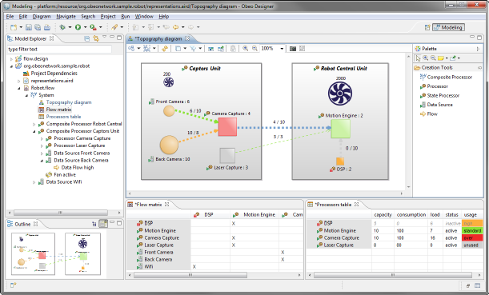

Figure 4. The Sirius Modelling Framework.

The Obeo corpora are composed by a set of three types of documents:

1. Java Concepts: a list of Java identifiers (i.e., classes, interfaces, methods, etc.) related to Sirius (see Figure 5 and Appendix 2).
2. Ecore Concepts: a list of concepts related to Ecore (the EMF meta model) and to Sirius (see Figure 6 and Appendix 2).
3. “TxStyle" Files[2]: a set of files in natural language (i.e., English) related to the documentation of the application being modelled by Sirius (see Figure 7 and Appendix 2).

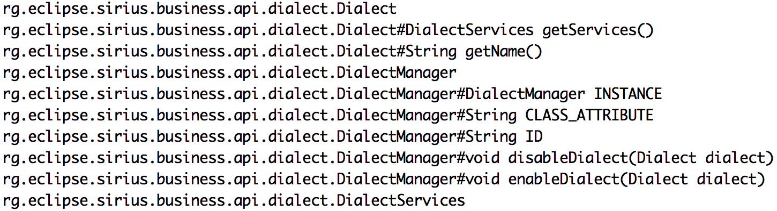

Figure 5: Java Concepts (fragment).

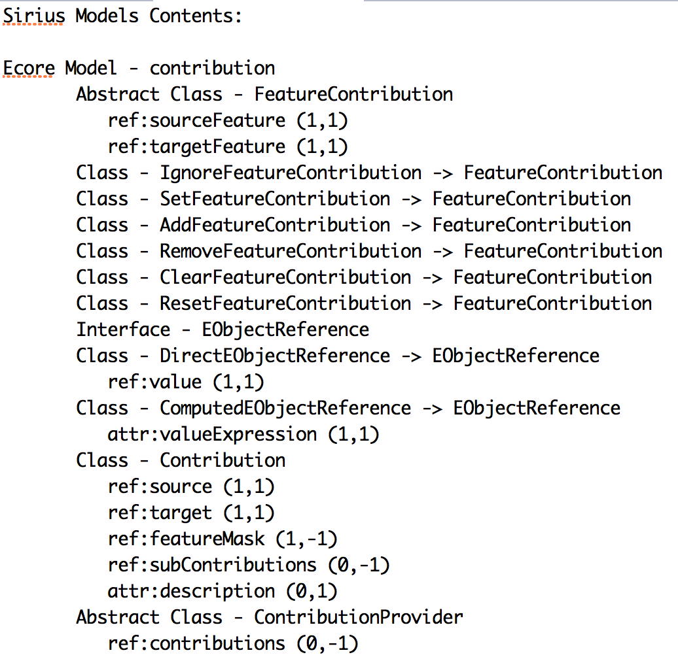

Figure 6: Ecore Concepts (fragment).

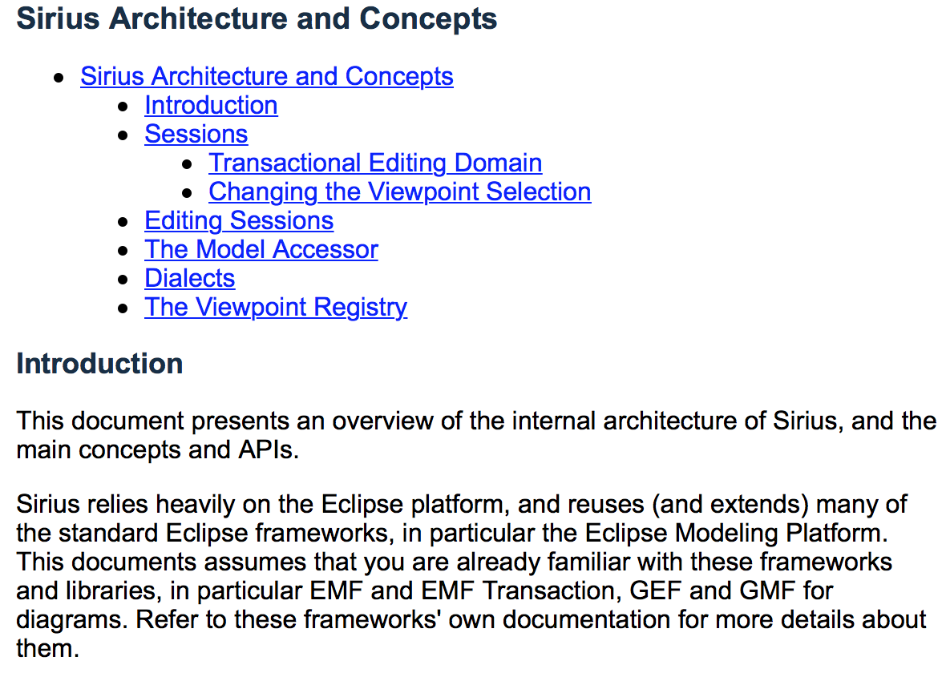

Figure 7: A “TxStyle” file (fragment).

By now, what we have developed is a basic prototype allowing to annotate the “TxStyle” files by establishing links to Java Concepts and to Ecore Concepts. Figure 8 shows how the annotation process is performed. The prototype can be accessed on the GitHub Model Writer repository (<https://github.com/ModelWriter/WP6/tree/master/EcoreConcepts-JavaConcepts-Annotator>).

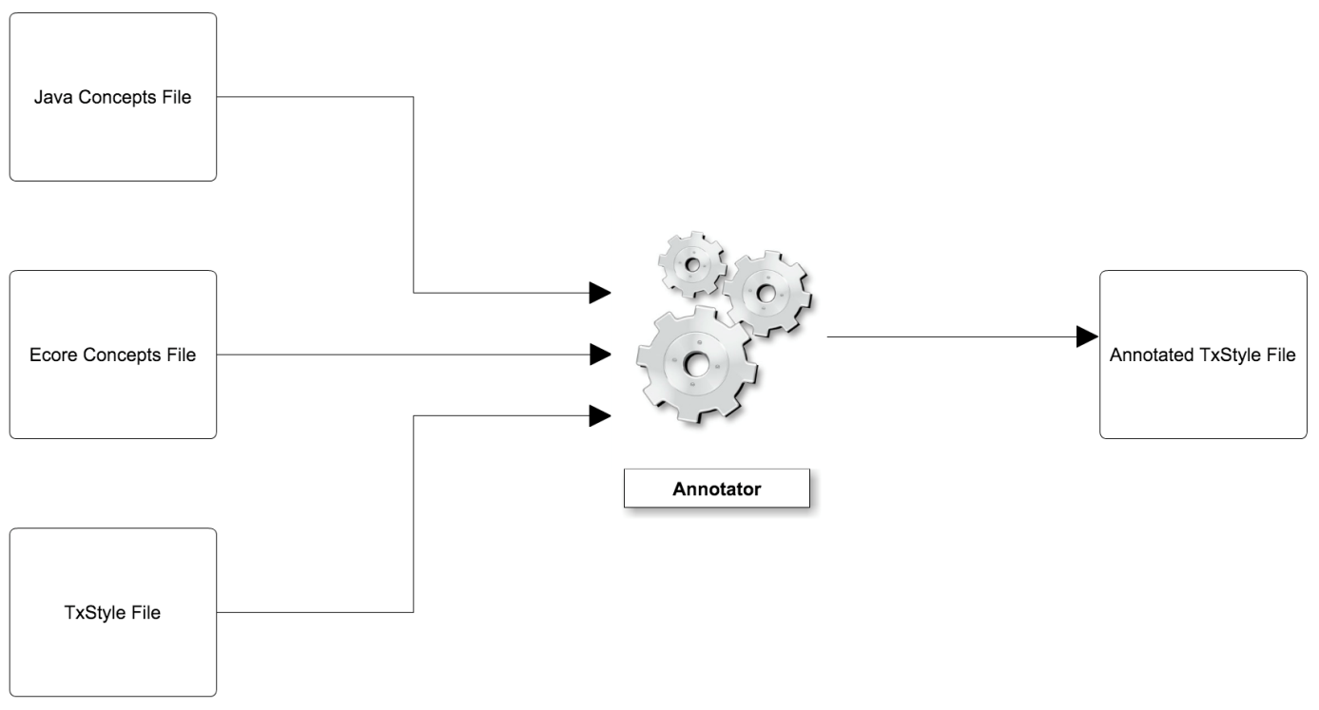

Figure 8. Annotating “TxStyle” Files.

Figure 9 shows a fragment of an annotated “TxStyle” file. Terms in red are related to Ecore Concepts and / or Java Concepts. Numerals represent line numbers.

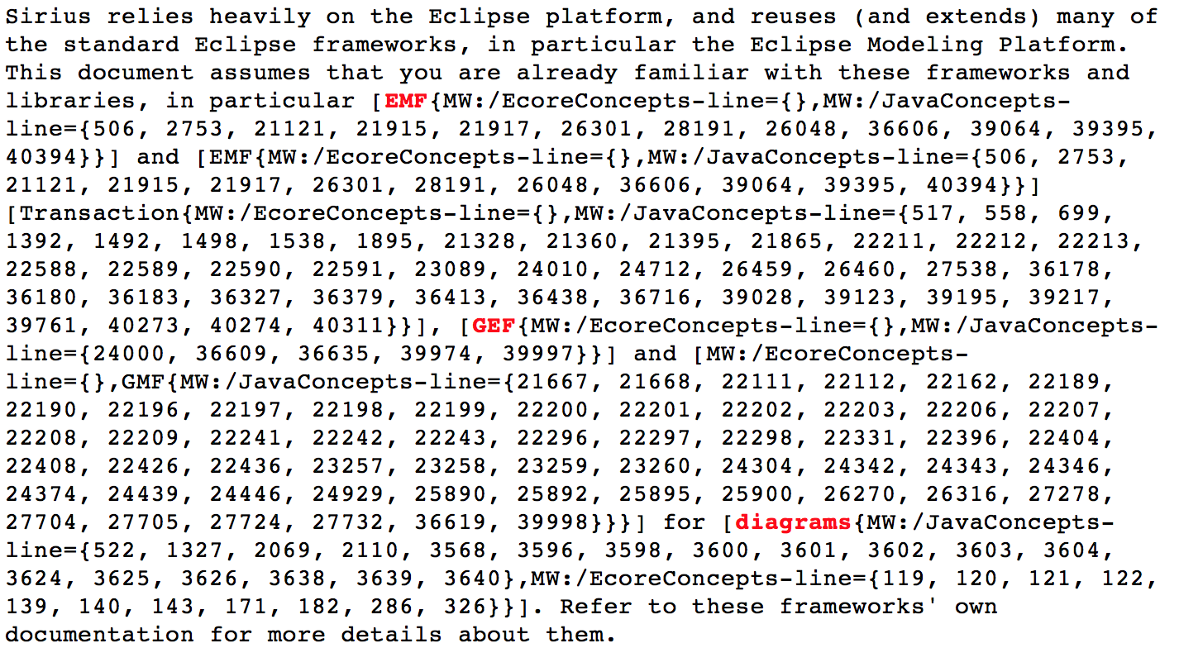

Figure 9. An annotated “TxStyle” file (fragment).

Appendixes

Appendix 1 Airbus Data

Example SIDP Document

<https://github.com/ModelWriter/French-Consortium/airbus/text/SIDP92A001V.docx>

Semi-structured design rules:

<https://github.com/ModelWriter/French-Consortium/airbus/text/rules.txt>

<https://github.com/ModelWriter/French-Consortium/airbus/text/rules.xsl>

Domain Model (RDFS Knowledge Base modelling plane components)

<https://github.com/ModelWriter/French-Consortium/airbus/kb/airbusComponentsKB_03072015.rdf>

RDF Knowledge Base derived from Semi-Structured Design Rules

<https://github.com/ModelWriter/French-Consortium/airbus/kb/rules.rdf>

Appendix 2 Obeo Data

Ecore Concepts File

<https://github.com/ModelWriter/Deliverables/blob/master/WP2/data/obeo/model/EcoreConcepts.txt>

Java Concepts File

<https://github.com/ModelWriter/Deliverables/blob/master/WP2/data/obeo/model/JavaConcepts.txt>

Example of a “TxStyle” file.

<https://github.com/ModelWriter/Deliverables/blob/master/WP2/data/obeo/text/Architecture.textile>

Example of a partially annotated “TxStyle” file

<https://github.com/ModelWriter/Deliverables/blob/master/WP2/data/obeo/text/ArchitectureAutomaticallyAnnotated.textile>

1. This first prototype is described in a paper that will be presented as a poster at SEPLN 2015. “Parsing Text into RDF”, Brahim Batouche, Claire Gardent and Anne Monceaux.
2. http://txstyle.org